**Ideation Phase**

**Define the Problem Statements**

|  |  |
| --- | --- |
| Date | 3 JUNE 2025 |
| Team ID | LTVIP2025TMID33932 |
| Project Name | Revolutionizing Liver Care : Predicting Liver Cirrhosis using Advanced Machine Learning Techniques |
| Maximum Marks | 2 Marks |

**Customer Problem Statement Template:**

Create a problem statement to understand your customer's point of view. The Customer Problem Statement template helps you focus on what matters to create experiences people will love.

A well-articulated customer problem statement allows you and your team to find the ideal solution for the challenges your customers face. Throughout the process, you’ll also be able to empathize with your customers, which helps you better understand how they perceive your product or service.

Reference: <https://miro.com/templates/customer-problem-statement/>

**Example:**

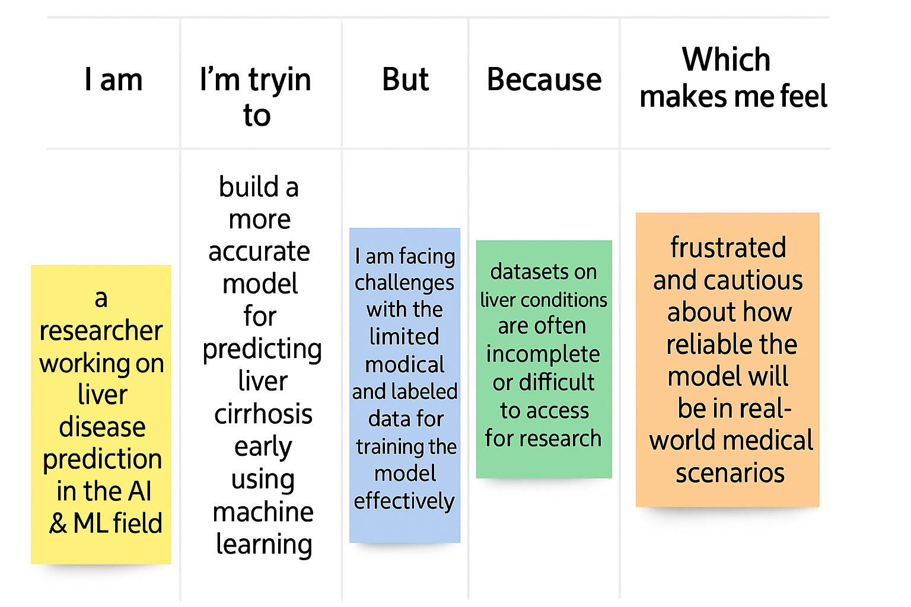

|  |  |  |  |  |  |
| --- | --- | --- | --- | --- | --- |
| **Problem Statement (PS)** | **I am (Customer)** | **I’m trying to** | **But** | **Because** | **Which makes me feel** |
| PS-1 | I am a healthcare professional, | I'm trying to detect liver problems in patients at an early stage, | But I lack accurate tools to predict disease risk in advance, | Because traditional methods rely on symptoms or delayed reports, | Which makes me feel uncertain and limited in providing timely care. |
| PS-2 | I am a person concerned about my liver health, | I'm trying to monitor and know my liver condition before it gets serious, | But I don’t know when to consult a doctor, | Because I don’t have access to easy, predictive health insights, | Which makes me feel worried, confused, and helpless. |